**VARUN KUMAR**

**2K19-IT-140**

**OOP LAB – 3**

Q1. Create a class employee with following details : name, age, empid, salary, experience,bonus

And use member functions : void setdata()// for setting the values //cin&gt;&gt;a;

Void print_data()//cout&lt;&lt;

Void assign_bonus() bonus= experience * 2000

And print_bonus() function to print the calculated value

CODE –

#include <iostream>

using namespace std;

class employee{

string name;

int age;

int empid;

int salary;

int experience;

int bonus;

public:

void setdata(){

cout<<"enter name: "; cin>>name;

cout<<"enter age: "; cin>>age;

cout<<"enter empid: "; cin>>empid;

cout<<"enter salary: "; cin>>salary;

cout<<"enter experience: "; cin>>experience;

cout<<endl;

}

void print_data(){

cout<<"name: "<<name<<endl;

cout<<"age: "<<age<<endl;

cout<<"empid: "<<empid<<endl;

cout<<"salary: "<<salary<<endl;

cout<<"experience: "<<experience<<endl;

}

void assign_bonus(){

bonus=experience*2000;

}

void print_bonus(){

cout<<"bonus: "<<bonus<<endl;

}

};

int main(){

employee E[2];

for(int i=0 ;i<2;i++){

E[i].setdata();

E[i].assign_bonus();

}

for(int i=0;i<2;i++){

E[i].print_data();

E[i].print_bonus();

}

return 0;

}

INPUT –

enter name: varun

enter age: 35

enter empid: 1

enter salary: 60000

enter experience: 3

enter name: rahul

enter age: 38

enter empid: 2

enter salary: 75000

enter experience: 5

OUTPUT –

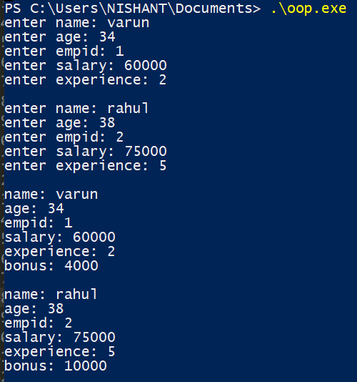

Q2. Create a class for student with fields : name, age, marks, group_allotted, grade,status(char)

Take the values from user

On the basis of first character of his name, he should be allotted a group: if(a-m): group A, B

otherwise

On the basis of marks allot grade: 90&gt; grade 0; 80-89- A; 70-79-B and so on..

On the basis of age, his status should be considered: E/N ie eligible to vote or not

CODE –

#include <iostream>

using namespace std;

class student{

string name;

int age;

float marks;

char group_allotted;

char grade;

char status;

public:

void setdata(){

cout<<"enter name: "; cin>>name;

cout<<"enter age: "; cin>>age;

cout<<"enter marks: "; cin>>marks;

}

void allot_group(){

if(name[0] >= 'a' and name[0] <= 'm' )

group_allotted='A';

else group_allotted='B';

}

void allot_grade(){

if(marks >= 90) grade='O';

else if(marks >= 80) grade='A';

else if(marks >=70) grade='B';

else if(marks >= 60) grade='C';

else if(marks >= 50) grade='D';

else if(marks >= 40) grade='E';

else grade='F';

}

void allot_status(){

if(age >= 18) status='E';

else status='N';

}

void print_data(){

cout<<"name: "<<name<<endl;

cout<<"group_allotted: "<<group_allotted<<endl;

cout<<"status: "<<status<<endl;

cout<<"grade: "<<grade<<endl;

}

};

int main(){

student S[2];

for(int i=0;i<2;i++){

S[i].setdata();

S[i].allot_status();

S[i].allot_grade();

S[i].allot_group();

cout<<endl;

}

for(int i=0;i<2;i++){

S[i].print_data();

cout<<endl;

}

return 0;

}

INPUT –

enter name: abhishek

enter age: 16

enter marks: 84

enter name: varun

enter age: 19

enter marks: 58

OUTPUT –

